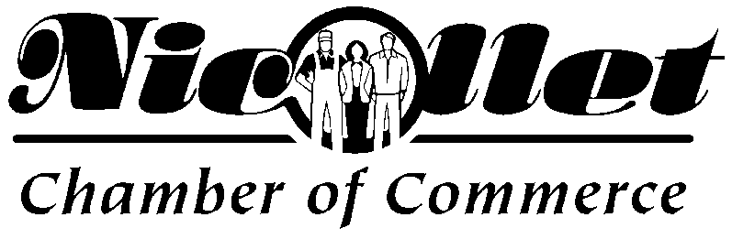
December 1, 2021
As you well know, 2021 started as challenging year for the Chamber, but we have come around and many of the traditional chamber activities that were planned were able to happen this year which has been a great feeling! We have started to plan for 2022 with hopes that it will continue to resume to what every normal may be! We are seeking your membership in the Nicollet Chamber of Commerce. We appreciate your consideration and look forward to working with you!
The Nicollet Area Chamber of Commerce was formed in 1977. It is a non-profit, incorporated entity supported by members’ annual dues and most recently, fundraising. Membership is voluntary and is made up of area businesses and professionals. You do not have to be a business to join; we welcome civic-minded individuals as well. We currently have a membership that is nearly 70, and we are always looking for more members.
We would like to update our contact information for all of our members so please completed the contact information on the enclosed form. We do sent emails about our happenings and want to make sure they are being directed to the correct person. Please send in your dues and information to us by January 15th, 2022.

Yours Truly,
Nicollet Area Chamber Board
Rhonda Ganger, Ann Wagner, Nora Wilking, Rick Hulke, Del Vulcan, Mark Gudmudson, and Erik Jensen

Mission Statement: As an organization representing ALL business and citizen interests of the community, the primary objective is the advancement of the economic and civic well-being of the entire greater Nicollet Area.

