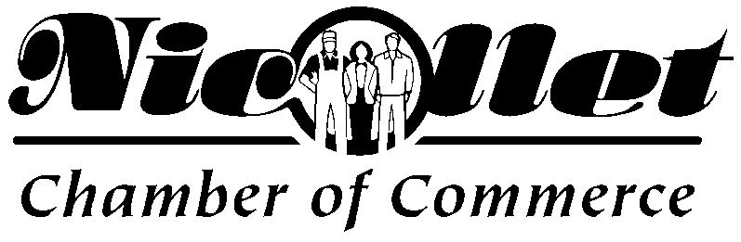
Membership Dues Structure – 2022
Business Membership ($100 Annual Dues) Those parties with an active business interest in the City of Nicollet and it’s vicinity. Businesses would include retail, manufacturing, service industries, financial, professional, agri-business, property management and utilities.

Business Owners with multiple businesses add $25 for each additional business

Associate Membership ($75.00 Annual Dues) Those parties that are considered a Direct Sales Business (direct selling includes sales made through home parties, one-on-one demonstrations, and other personal contact arrangements as well as internet sales.) Examples include MaryKay, Tastefully Simple, Scentsy, etc.
Honorary Membership This includes civic / community organizations, churches and schools.

Friends of the Chamber Membership ($50 Annual Dues) Individuals that do not fit into any other membership category that are community minded citizens/retirees who wish to support the objective of
the chamber.

Chamber Membership Benefits:
Referral Service – The Chamber receives requests for business, product, or service information. Your chamber forwards only the names of its members.
Internet Exposure – Your Chamber and City of Nicollet developed and maintain Nicollet’s official website – www.nicollet.org.
Chamber Bucks Program – Chamber currency encouraging doing business in Nicollet.
Networking Opportunities – Chamber provides opportunity to get to know and communicate with fellow business owners at Chamber sponsored socials.
Sponsorship Opportunities –Through Chamber membership you help to sponsor dozens of events and activities in Nicollet’s schools and the community at large.
Here is a list of some of the Chamber’s Annual Events and Activities:
Spring/Fall City Wide Garage Sales Support Numerous School Acitiviteis
Nicollet’s National Night Out Friendship Days Sponsorship
Small Business Saturday / Hometown Holiday Fall School / Educator Social(s)
Support Welcome to Nicollet Sign Project Purchased Welcome to Nicollet light pole banners
Nicollet.org Website Purchase Holiday Lights for street poles
Trunk N’ Treating Sponsor Holiday Light Contest
Membership Drive Support the Crusin’ on Pine & 99 Roll In
Chamber Mission: The Nicollet Chamber of Commerce is an organization representing Nicollet business and industry, working together to advance the economic wellbeing of its members and the community. The Chamber’s purpose is to create a better place to live, work and do business.

